
CS 111 – Programming Fundamentals
Lab # 06
Loops in C++ (for, while, do-while)

––
Student Name: Athar Imran
Student ID: 2604277

Assignment Date: 13th October, 2026
Assignment done: 15th October, 2026
Due Date: 16th October, 2026
Contents
Secure Login Simulator 3
Program: 3
Outputs: 5
Analyze the code 6
Write the exact output of the program. 6
What does the continue statement do in the first loop? 6
Why does the do-while loop run once even though the condition n > 10 is false after the first pass? 6
How would a while loop with the same condition behave differently? 7

ATM Menu Selection (Switch)

Program:
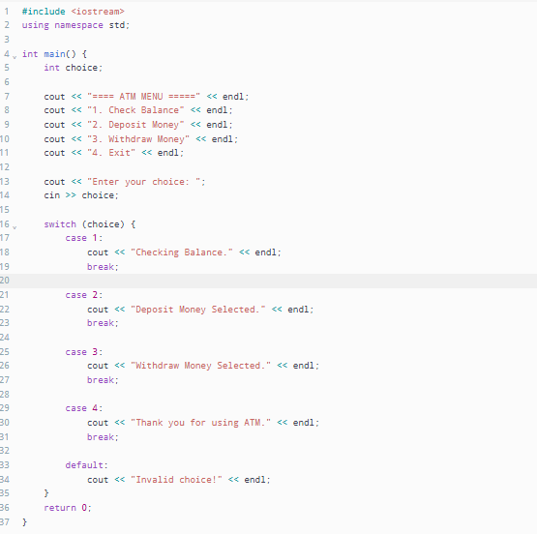

Outputs:
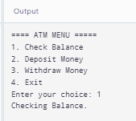
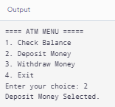
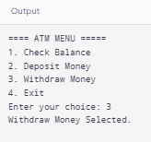
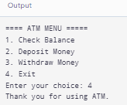
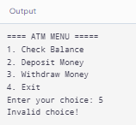

Integer Digit Summation (While Loop)

Program:
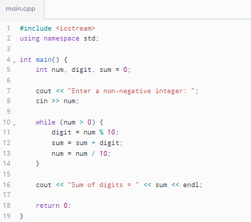

Outputs:
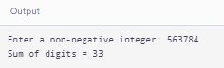
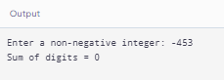

Validation and Average (Do While Loop)

Program:
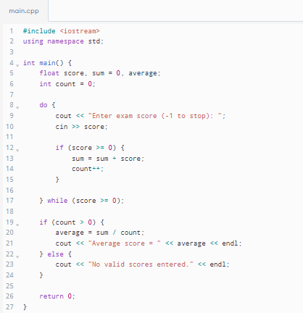

Outputs:
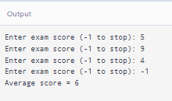
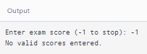
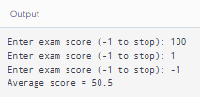

Right-Angled Number Triangle (For & Nested Loops)

Program:
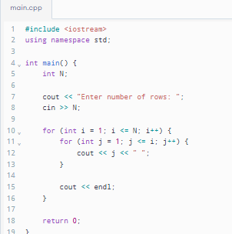

Outputs:
